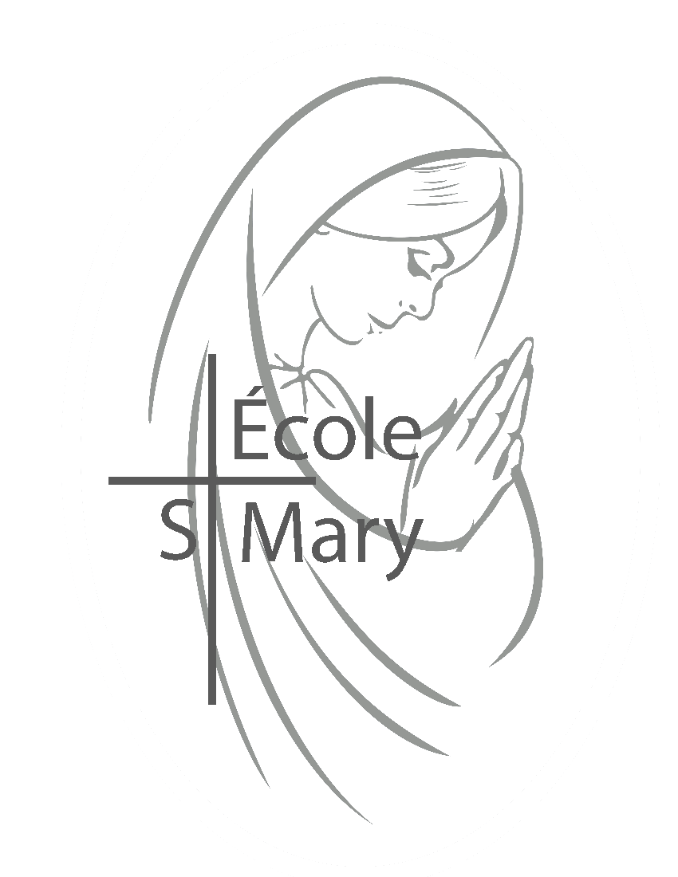
Have a Great Summer!
All students’ belongings should have been taken home on the last day of school. June 28th , however, the office staff are at the school for a couple extra days to help you before summer vacation.
The office will be closed for summer vacation and Open on AUGUST 22nd to start the new school year.
Here is some information help you during the summer holidays. You can also leave send emails to esmoffice@holyspirit.ab.ca that we will respond to when we return on August 22nd. If you require immediate assistance you can call the Holy spirit Board office.

Bell Times for Next Year
Grade 1 – 6’s Mon – Thurs. 8:00am – 3:00pm
Fridays 8:00am – 12:30pm
Kindergarten Mon – Fri. 8:00am – 11:00am
1st kindergarten Friday off each month – Please see the Calendar
Early Learning Mon – Thurs 8:15am – 11:15am

DID YOU?
*Complete the Registration form for next year?
-We need this completed so we can assign your child to a class.
*Complete the Transportation Registration so your child can ride the bus?
-Your child will not be allowed to ride on a bus until this is completed
-Fee Paying must pay BEFORE you can ride
Questions you may have?
When will I know who my child’s teacher is?
- Emails will be sent out the week before school starts to let you know the teacher assignment and the Zone door your child is assigned to.
How do I tell the school I’ve changed my mind and my child is moving schools?
- Email esmoffice@holyspirit.ab.ca with an official withdrawal request. We will receive this when we return to the office on August 22nd.
How do I register my child(ren) for bussing over the summer?
- Through your parent Powerschool Account through School Engage.
If you are having issues completing this task you can wait till the office is open or contact the board office.

Samaritan Stars:
As the students do good deeds and display exemplary actions/attitudes, their fellow classmates can nominate them and put their name in the “Samaritan Stars” jar. From here we draw names to win a cheque for $25.00 which is graciously donated by Ward Bros. Construction. Thank you, Ward Bros., for your continued generosity to our school!
For the month of May our winners were: Kimberly K (3ME) and Zoe B (2GE)
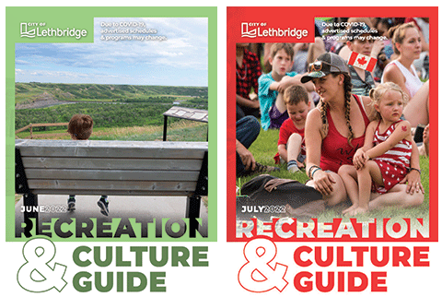
Events Around Lethbridge
CANADA DAY at Galt Gardens
9am-4pm
Artists and Performers showcasing Canadian cultural diversity, traditions and music.

CANADA DAY in Lethbridge
Henderson Lake Park
12pm-11pm
Live Entertainment, Food vendors,
KidZone, Fireworks
https://www.lethbridge.ca/Things-To-Do/Leisure-Guide/Pages/default.aspx
Stormwater Programs
Paint Yellow Fish by storm drains that say "RAINWATER ONLY" Get Involved Today!!
www.lethbridge.ca/yellowfishroad
2022 BLITZ DAYS
Wednesday July 13
Rideau Park North 10am-12pm
Wednesday August 17th
Redwood Park South 10am-12pm

YWCA NEIGHBOURHOOD PLAY PROGRAM
Free summer drop in program Children aged 6-12
July 4th-August 18th
Mon through Thursday
Morning Session 9-12
Afternoon Session 1-3
No supervision over the lunch hour, children may attend both sessions but they must leave the site over the lunch hour
Pre-registration is not required, just show up
Southside Schools Westside Schools
Ecole Agnes Davidson Mike Mountain Horse
Lakeview School Gerald B Probe
Fleetwood Bawden

House Keeping Items:
- Send a Water Bottle with your student. There are fill stations but no water fountains. We don’t know what will happen next year so Water bottles are still encouraged!
- If you have moved, please email esmoffice@holyspirit.ab.ca with your address change.
- Our monthly newsletter is sent out at the beginning of the month and can be found on the website.

Dear ESM Families,
Happy Canada Day! We have just a few words and some information as we sail off into summer.
First off, we would like to thank you for entrusting us with the care of your children. What an honour. To our grade 6 students and their families, thank you. We are also saying good bye to many families that have been with us for many years. Thank you for allowing us to journey with your child and your family. We wish you the best on your new adventures. To all of our ESM families, may God Bless you and keep you. Thank you for a wonderful school year.
Mr. Monaghan is officially heading off into retirement. Thank you for leading us over the last nine years here at ESM. We wish you all the best and we will miss you! God Bless.
We have a few information items for you. You will find the calendar, school start dates, and important dates in this newsletter. The office will be closed for the summer and will reopen August 22, 2022. We welcome Grade 1-6 students back to school on Wednesday, August 31st, and Kindergarten students back on September 12th, 2022. You child’s class placement will be sent home in August. We are really looking forward to the new school year with endless possibilities.
We will be welcoming new staff members. Justin Harper will be joining us as our Associate Principal. Angela Court as our English Kindergarten teacher. Kevin Toews will be teaching English grade 6 class for the upcoming school year. We look forward to welcoming them to the ESM school community.
Please mark your calendars for our Opening Mass, Monday September 19th, 9:00 am at Assumption Parish. We will be having our Welcome Back BBQ that evening as well. We look forward to celebrating with you!
Next year, we will be moving away from the report cards we currently use, to digital reporting. The program is called Spaces. A letter about Spaces came home with your child. We are looking forward to sharing your child’s learning journey with you as they learn and grow.
Thank you to our students, families, staff and School Council, for making ESM such a great place to be. We are excited to continue our partnership in your child’s education. We wish you a restful, rejuvenating, fun, and blessed summer from the ESM Staff. See you in August!
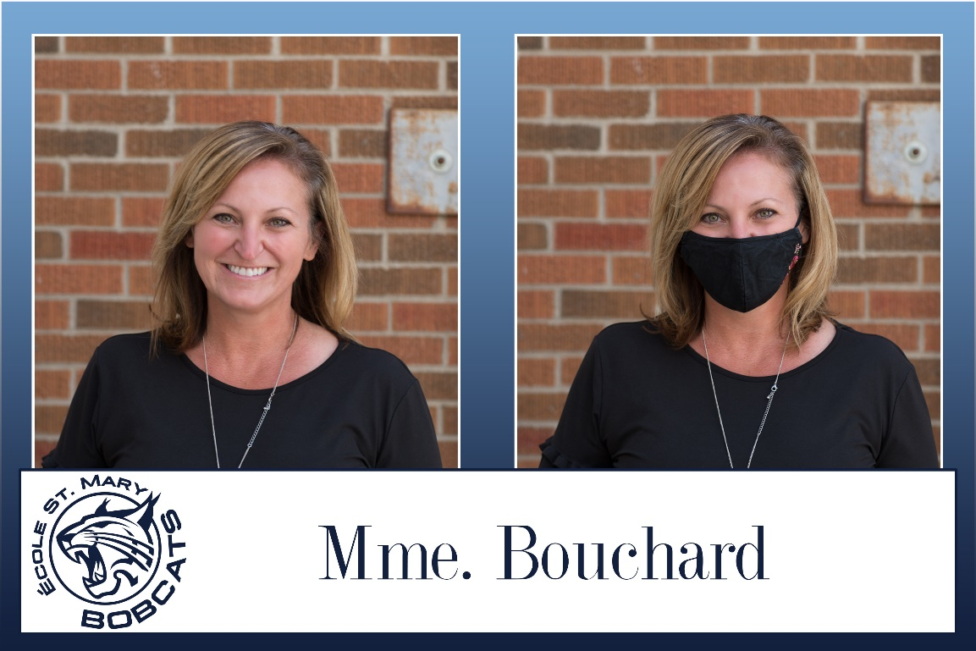
Kiera Bouchard

August 2022 Calendar
Sunday | Monday | Tuesday | Wednesday | Thursday | Friday | Saturday
 | 1 | 2 | 3 | 4 | 5 | 6
7 | 8 | 9 | 10 | 11 | 12 | 13
14 | 15 | 16 | 17 | 18 | 19 | 20
21 | 22  OFFICE OPEN | 23 | 24 | 25  Opening Mass for Staff | 26 | 27
28 | 29 | 30 | 31  FIRST DAY FOR STUDENTS Gr.1-6

September 2022 Calendar
Sunday | Monday | Tuesday | Wednesday | Thursday | Friday | Saturday
 |  |  |  | 1 | 2 | 3
4 | 5  NO SCHOOL  Labour Day | 6 | 7 | 8 | 9 | 10
11 | 12  FIRST DAY for Kindergarten | 13 | 14 | 15 | 16  NO Kindergarten | 17
18 | 19 | 20 | 21 | 22 | 23 | 24
25 | 26 | 27 | 28  Div. Board Meeting | 29 | 30  NO SCHOOL  Day for Truth and Reconciliation

